This project uses a machine learning model to predict the calories burned during exercise based on user inputs such as heart rate, exercise duration, weight, height, age, and body temperature.

Features

• User Inputs: Users can input personal details like age, height, weight, exercise duration, heart rate, and body temperature.

• Model: The project uses the XGBRegressor model to predict the calorie burn based on the provided input data.

• Data Scaling: Data is standardized using StandardScaler to improve prediction accuracy.

• Visualization: Displays an image with a caption to illustrate the application.

Data • Calories Data: The target data for calories burned, provided in calories.csv.

• Exercise Data: The feature data for each exercise session, provided in exercise.csv.

1.Data Processing: Loads and scales exercise data.

2.Model Training: Trains an XGBoost regression model on the provided data. 3.Prediction: Predicts the calorie burn for the user's inputs.

4.Display Results: Displays the predicted calories burned.

Requirements

• Python libraries: streamlit, pandas, numpy, scikit-learn, xgboost, PIL

The Dataset used for training the model in colab was taken from kaggle,the zip file consisted of 2 csv files.

**DATASET LINK :** <https://www.kaggle.com/datasets/fmendes/fmendesdat263xdemos/data>

The Model Training Code can be accessed via Colab Link-:

**COLAB LINK :** <https://colab.research.google.com/drive/1jGfin_NBlQiKOnlEZPptPmkB8yKX5XlT?usp=sharing>

**1.TRAINING AND TESTING OF MODEL**

A Brief about the steps followed : for training the model:

1. Import Libraries: Import essential Python libraries like pandas, numpy, scikit-learn, xgboost, and streamlit.
2. Data Loading: Load the calories.csv and exercise.csv files using pandas to get both the target (calories burned) and feature (exercise details) data.
3. Data Preprocessing: Merge Data: Merge the exercise and calories datasets based on the session or user ID for a complete dataset. Standardization: Use StandardScaler to scale features such as heart rate, age, weight, height, exercise duration, and body temperature, which improves model accuracy.
4. Model Selection and Training: Model Choice: Choose the XGBRegressor model, a gradient boosting model optimized for regression tasks. Train Model: Train the XGBRegressor on the preprocessed data, using calorie burn as the target variable.
5. Prediction: Collect user inputs for personal details and exercise metrics. Use the trained model to predict calories burned based on these inputs.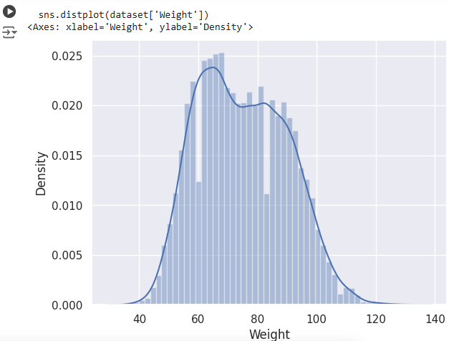

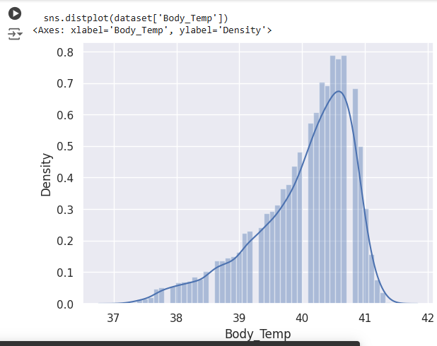

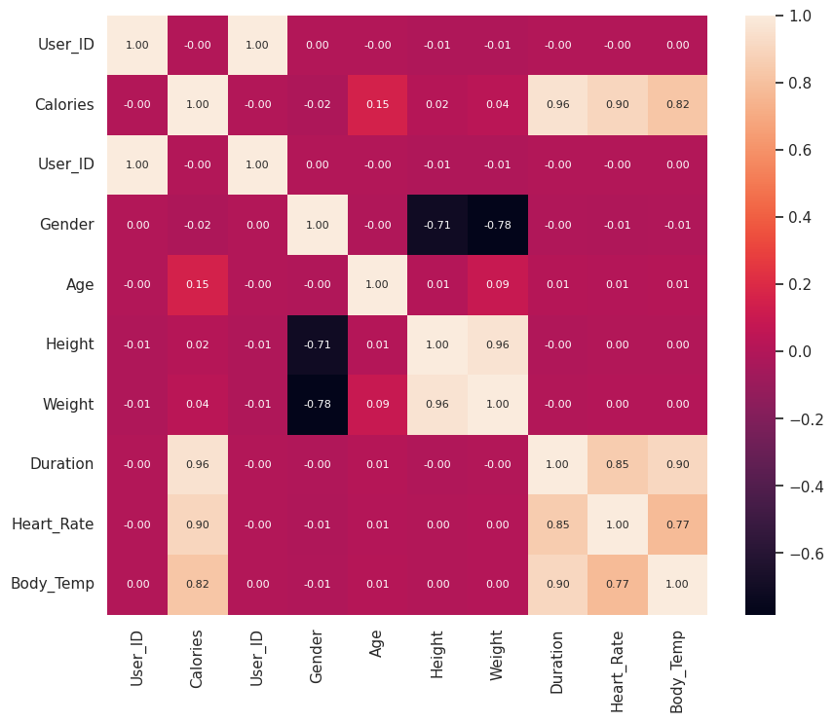

**2. DEPLOYMENT**

Deployment of the model is done on Streamlit,for that on VS Code make a requirements.txt file and in the terminal run the following command

' pip install -r requirements.txt ' .

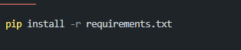

After that for code you can refer to ‘ Streamlit_Deployment.py .’ part of this repository.

Now to run streamlit in a browser run the following command in terminal:

‘ Streamlit run cpm.py ‘ (#streamlit run filename.py).



And Voila !,Your project is deployed successfully.